**When you run the installer, you may see the next screen:**

**Why Does SmartScreen Block Apps?**

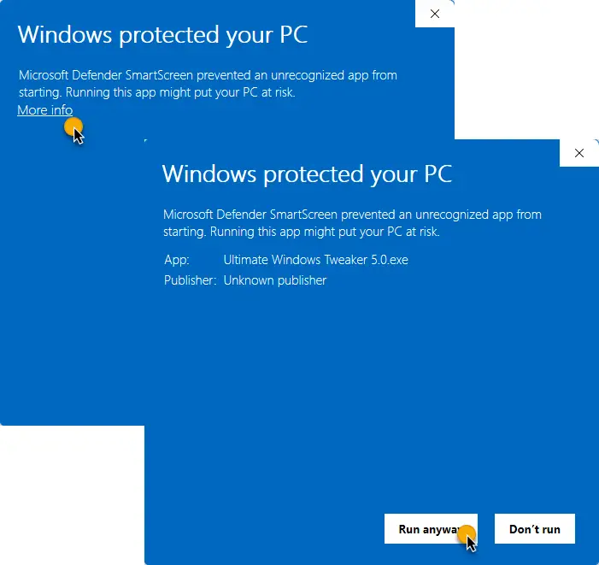

SmartScreen blocks apps for a couple of reasons:

1. **Unknown Publisher**: The app is from an unknown publisher or hasn’t been widely downloaded.
2. **Potential Threat**: The app could potentially harm your PC.

**How to Bypass the SmartScreen Warning**

If you’re confident that the app you’re trying to run is safe, you can bypass the SmartScreen warning by following these steps:

1. **Click on ‘More info’**: When the SmartScreen warning appears, click on the ‘More info’ link.
2. **Run Anyway**: After clicking ‘More info,’ you’ll see a ‘Run anyway’ button. Click it to run the app.

**How to Unblock an App Permanently**

If you frequently use an app that SmartScreen blocks, you can unblock it permanently:

1. **Right-click the File**: Navigate to the file, right-click it, and select ‘Properties.’
2. **Unblock the File**: In the ‘General’ tab, check the ‘Unblock’ box and click ‘Apply’.

**Disabling SmartScreen (Not Recommended)**

While it’s possible to disable SmartScreen, it’s not recommended due to the security risks. However, if you must, here’s how:

1. **Open Windows Security**: Go to ‘App & browser control’ in Windows Security.
2. **Turn Off SmartScreen**: Under ‘Check apps and files,’ select ‘Off’.

**All steps can be removed by signing the installer. The cheapest certificate for open-source software costs about 70 €. If this amount is collected from voluntary contributions (PayPal), the certificate will be purchased, and the installation will be seamless.**